Geographic Location Criteria

Learning Objectives
- Evaluate different considerations on where to place a large-scale data center

Geographic Location Requirements
For a large multinational corporation, there is a good chance that it already has a number of servers at each of its branch offices and would likely build traditional data centers in the countries in which it is already established. The reason for having equipment closer to the users is for better application responsiveness, which (hopefully) yields higher productivity.
A company whose product is Web based would need to build multiple data centers around the world to provide better service to customers in a wide variety of geographic locations. A common example of this is Web search—Google, Microsoft, and Yahoo! all have large data centers at many sites scattered around the globe. This variety in location provides faster search results to the user, which is a competitive advantage (as long as accuracy is maintained).
A third category of companies that require large data centers are Web hosting providers. They offer server(s) to host the website for companies of various sizes. Small companies might need to have their site hosted in only one location to serve local customers. Large companies might have several different regional sites but would prefer to deal with one hosting company rather than a different one in each region.
An organization in any of the above categories would have similar goals when it comes to picking the location of a new data center. In order to satisfy the facility's needs, it is necessary to locate a data center where there are adequate electrical power suppliers. For the "green" conscious, one might look for an electricity supplier that uses hydroelectric, solar, wind, geothermal, or other renewable energy sources. Regardless of the source of the power, it is desirable to work with a utility company that is willing to negotiate bulk-purchasing agreements, which lock in a specific discounted price per kilowatt hour for several years.
In addition to power, if you want to take advantage of evaporative cooling techniques mentioned earlier in this unit, your data center should be located near an adequate water supply. There are also instances in which you can locate near a lake/reservoir that is naturally cold, use that water as your cold supply, and return it after tempering (lower the temperature by mixing again with cold water from the same source).
For a smaller scale data center, another factor to consider is the cost of real estate and taxes. For a large deployment, however, the cost of the IT and facilities equipment are much higher than the cost of land, and monthly energy costs far outweigh any taxes.
There are also basic logistics that are desirable to have available to support the data center and its life cycle. A supply chain is needed to procure the goods and services, not just servers but all equipment and building materials. There also should be adequate ports/rails/highways to deliver standard shipping containers (40' × 8' × 8'6"; or 12.19m × 2.43m x 2.59m) to your site. Small and medium sized data centers will typically buy servers from companies such as IBM, Dell, or HP, whereas big companies have custom servers, but none of these are manufactured on site and so have to be purchased and delivered. Containerized/modular solutions do more of the manufacturing off site so that installation is faster at the data center. Recycling of raw materials should occur at the end of the life span of the hardware or for failed components, such as hard drives, so recycling availability should also be considered.

Weather
Also mentioned in the previous module was economization, or mixing of colder outside air with the hot air expelled from the IT equipment. In Figure 2.16, you will notice different colored bands. In regions of yellow or orange, you could use outside cooling during the colder seasons, and in regions of green and blue, you could likely use outside cooling year round. Regions marked as red could still use outside cooling but for a few months of the year. For example, because of its cold average climate and renewable energy sources, Iceland has a growing data center industry.
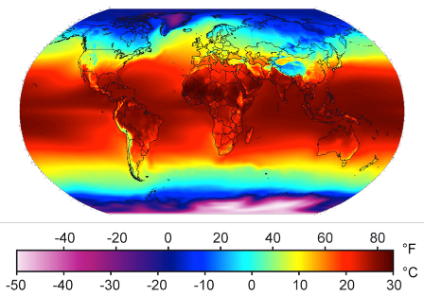Figure 2.16: Global average temperature map (Wikipedia, 2014).
As you will see in the power usage effectiveness (PUE) section later in this module, the energy utilization will be higher during hot months and lower during cold months. This is due to the efficiency gains from "free cooling" (either using air economizers or naturally cold water.)
The average amount of annual rainfall might be a factor if you are considering using rainwater storage/filtration as a water source for cooling your data center. However, the number of sunny days per year in a particular region might convince you to try solar.
Part of a risk assessment for a particular location would include the frequency of natural disasters in the region, such as floods, hurricanes, tornadoes/cyclones, tsunamis, and earthquakes. As you can see in Figure 2.17, different regions have varying levels of susceptibility to a potentially damaging event.
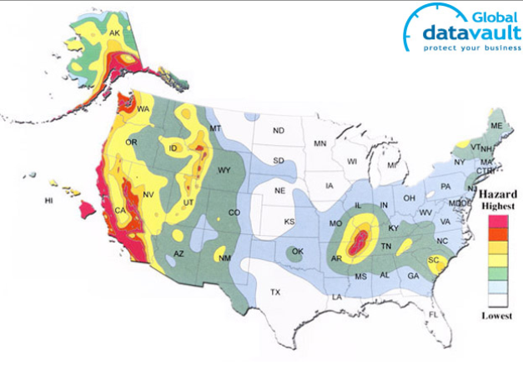(a) Earthquake risk map. | 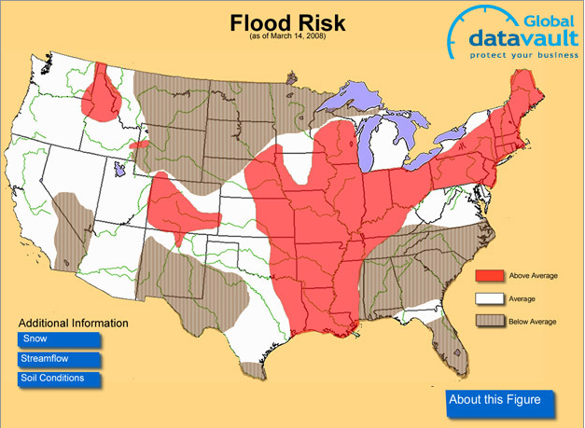(b) Flood risk map. | 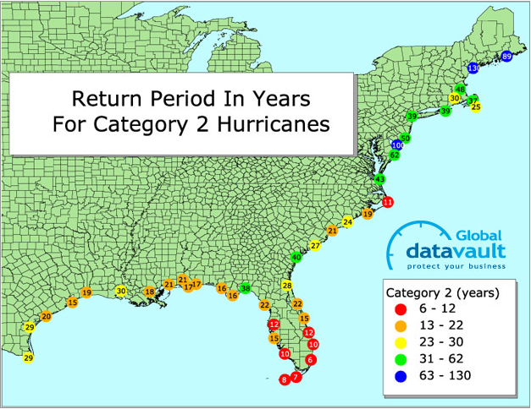(c) Hurricane risk map. | 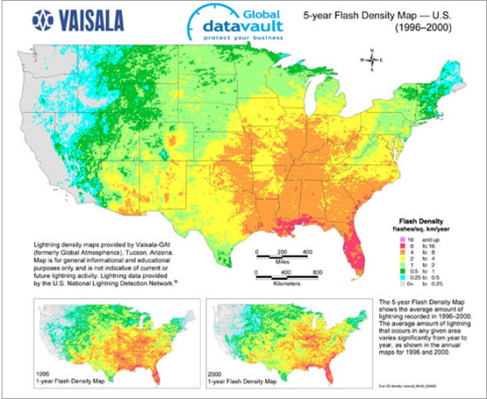(d) Lightening risk map.

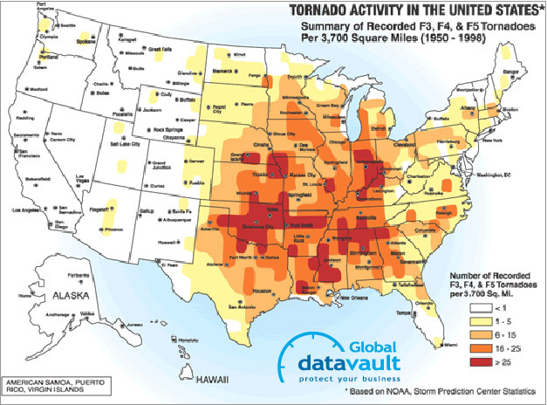(e) Tornado risk map. | 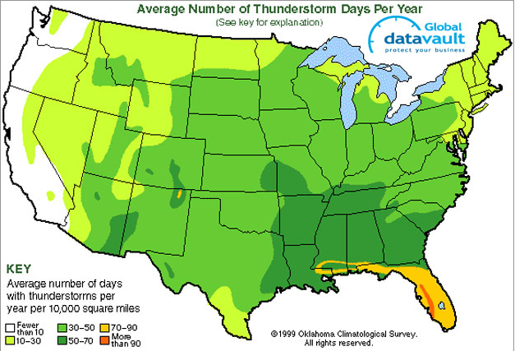(f) Thunderstorm risk map. | 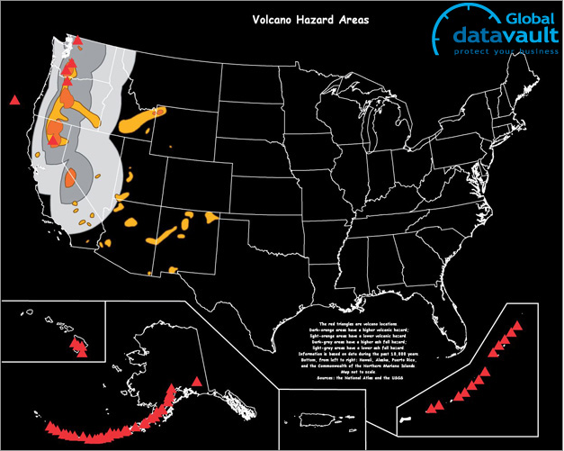(g) Volcano risk map. | 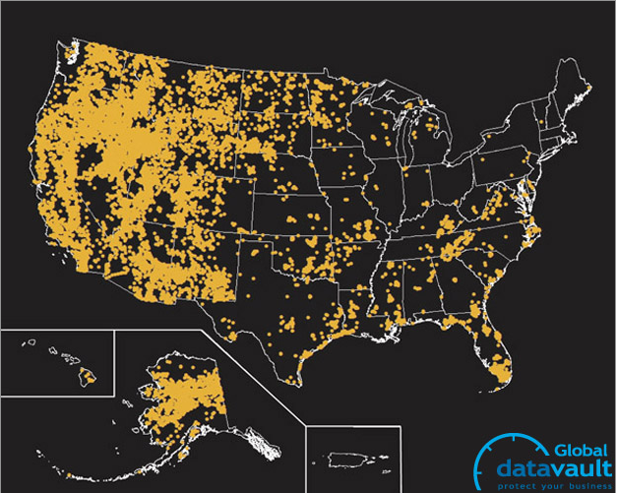(h) Wildfire risk map.
Figure 2.17: Natural disaster threat maps (Global Datavault, 2013). (Click on each figure for an enlarged view.)
As a cloud user, or cloud provider, it is beneficial to have two (or more) geographically distinct data centers for your services to mitigate risks of natural disaster, excluding large asteroid impacts, of course.
did I get this

Geographic Location

Connectivity
As broadband adoption among consumers continues to grow, the effectiveness of cloud computing will increase. You can find trending graphs and current broadband adoption at Akamai.
The Internet relies on fiber optics to send and receive data over long distances. Figure 2.18 shows the relationship between multiple tiers of the Internet, in which tier 1 providers own the actual fiber cables, the network equipment, and the buildings they are housed in; tier 2 providers own large networks as well and peer with (have connections to) other tier 2 providers but also have to lease some connections from tier 1 providers in order to reach the whole Internet; and tier 3 providers are only resellers, which provide connections to end users. A single corporate entity, such as Verizon in the United States, may provide services at all tiers.
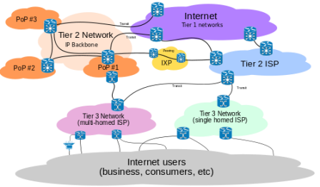Figure 2.18: Internet connectivity (Wikipedia, 2014).
In order to support a large amount of users, a cloud provider should choose a data center location that is in a city/region that has a tier 2 or tier 1 provider. This will also decrease the latency to global users due to fewer hops (each router is a hop) between the client and the server. A data center's requirement for uplink to the Internet ranges from a few megabits per second to several hundred gigabits per second, and that much bandwidth simply is not yet available everywhere.

Data Center Costs
As you may recall from Unit 1, organizations have to deal with capital expenses and operating expenses for their IT projects. For new companies with an anticipated need for many servers, or for existing companies that have outgrown their existing infrastructure, a decision must be made to build a new data center, expand existing facilities, or migrate some (or all) of their IT services to a cloud provider. With rising energy costs, companies with existing (but outdated) data centers would also consider building a new data center or retrofitting the existing one with new power/cooling. Many scenarios, such a retrofit, might cause unacceptable downtime, so they would instead choose to go to a new location and migrate servers/services from the old location to a new data center. In any of the above scenarios, a detailed cost analysis would be helpful in making the decision (and likely required before any budgetary approvals).
Prices fluctuate often. What was valid in 2011 might not be valid in 2014. The intent of this section is not to give you the tools to do an entire cost analysis on your own but rather to help you understand the types of expenses that go into building a data center.

Capital Expenditures (CapEx)
Capital expenses (which occur only once) for data centers include upfront planning, cost of property and/or construction, facilities equipment (power, HVAC, safety, and security), as well as IT equipment (servers, network switches, initial network connectivity). A more detailed explanation of each follows:
Upfront planning: Upfront planning design costs account for a significant portion of CapEx. This typically includes feasibility and impact studies, architectural design, engineering design, project management costs, and contingency costs. A recent Forrester research study [1] estimates these costs to range from 20% to 25% of the total cost for a typical data center.
Property costs: A principal expense incurred in building data centers is the cost of property. This, of course, varies significantly depending on location. Organizations typically have the option of either constructing a building from scratch or to repurpose an existing building to be a data center.
When building from scratch, many costs, such as the real estate transaction, consultant, brokerage, and building permits, apply in addition to the actual cost of building the data center "shell," which could include excavation, grading, roadways, utility connections, and physical security. Reed Construction Data has estimates for the United States and are typically between $200 to $300 per square foot, depending on the type of building and labor.
Many organizations opt to repurpose existing buildings, particularly those that have been abandoned, such as factories or mills, among others. Google's Hamina data center in Finland was repurposed from an old paper mill. Barcelona Supercomputing Center is an example of an old chapel repurposed as a data center site.
Leasing a building or subleasing space in a building can also be done, shifting this capital expense to an operating expense.
Facilities equipment: Some heavy equipment is often installed during the construction phase, and once the building shell is complete, data center–specific facilities can be built, and equipment needs to be procured and commissioned. This includes most of the equipment outlined in the "Facilities" page in the "Data Center Components" module, such as cooling (CRACs, chillers, condensers, water tanks), electrical equipment (power distribution, generators, transformers, UPSs, automated transfer switch), and fire detection and suppression systems (FM-200).
Estimates for the cost of HVAC and electrical equipment are approximately $7,000 to $20,000 per kilowatt of IT load. [1] In addition, fire suppression systems costs can range from $20,000 to $60,000 for a typical data center spanning several thousand square feet.
IT equipment and connectivity: Once the data center facility is ready, equipment can be moved in and installed. Typically, this involves purchasing rack-mountable servers and networking and rack power distribution equipment. In larger data center environments, it is becoming increasingly popular to roll out fully containerized servers with integrated power, cooling, and network management. IT equipment costs can vary widely depending on the size and configuration of the hardware.
In addition to IT equipment, the data center needs to have a dedicated network connection in order for it to be accessible to the organization that is using it. Network service providers typically charge an upfront average of $10,000/mile to install and commission fiber to a data center. [1]

Operating Expenditures
Operational expenditures (periodically recurring) for data centers typically include electrical power, staffing, cooling/HVAC, Internet uplink, maintenance, taxes, and/or leasing.
One of the biggest operational expenses in running a data center is the power, and it can account for approximately 70% to 80% of the overall cost of running a data center. [1] Electrical utility charges to industrial sectors (which differs from residential pricing) can vary significantly from state to state and country to country. In the United States, the Energy Information Administration (EIA), an entity within the U.S. Department of Energy, publishes regular reports on power costs broken down by state and sector. TheInternational Energy Agency (IEA) publishes energy data for other countries as well. It is also important to note that the cost of power has been rising over the past few years. [2] Because power forms a large percentage of operational expenses and total cost of ownership (TCO), large data centers tend to be placed in regions with cheaper sources of power, whenever possible.
Staffing: Even though data centers can house thousands of servers, they are relatively efficient in terms of number of personnel per server. However, data centers still need a number of operational staff such, as twenty-four seven security and an on-site engineering staff. In countries in which labor is expensive, this cost will end up being the second-largest recurring expense after power. These costs can run into hundreds of thousands of dollars per year, depending on the location and staffing levels.
Cooling: Cooling costs also amount to a significant portion of data center expenses. According to a study by the American Society of Heating, Refrigerating, and Air Conditioning Engineers (ASHRAE), data center cooling consumes 42% of the total power drawn by traditional, inefficient data centers. [3] Many organizations are now paying attention to new techniques to reduce the amount of power required to keep a data center cool. ASHRAE has also published thermal guidelines for data center designers to plan and correctly configure cooling systems to maximize efficiency.
Connectivity: In addition to upfront installation and commissioning costs, network connectivity is usually charged monthly or quarterly from a service provider. The fee is typically in the range of several hundred or thousand dollars per month, based on the bandwidth and reliability guarantees of the connection. [1]
Maintenance: Purpose-built data centers also incur significant maintenance overheads in order to keep the facility running smoothly and to minimize downtime. This cost could be 3% to 5% of the initial construction costs. [1] In addition, facilities equipment may need periodic replacement or repair. For example, UPS batteries are replaced once in 5 years, on average.
Taxes and/or leasing: Building permits are required when building new data center shells or if an existing building's structure is altered significantly. Organizations also need to pay some form of annual property tax on the property owned. This cost, like others, can vary considerably from region to region. Average taxes are estimated to be $70 per square foot in the United States. [1] If you are leasing a property, many of these taxes are included in the monthly price of your lease.

Server Utilization
As you recall from the introduction unit, multiple servers are virtualized and consolidated onto fewer physical hosts to increase utilization and decrease energy costs. This improvement is helpful, but the demand for IT-related services in organizations continues to grow, as does the number of Web-based startup companies, which have a higher proportional demand for IT equipment.
Video 2.4: Data center efficency.
To see why server utilization is important, let us discuss power consumption when a server is idle (the CPUs are not doing anything, but the HDDs are spinning, and RAM and I/O devices still consume power) versus when the server is at maximum load (when all CPUs are at 100% utilization).
To estimate the power consumption (P) at a specific utilization (n%) use the following formula:
Pn =(Pmax − Pidle )×n100+Pidle
Through empirical measurements, this approximation is accurate to within ±5% across utilization rates.
did I get this

Power and Efficiency: Utilization
If an organization wants to decrease its overall monthly operating expenses, it has to do so both inside the rack and outside the rack, and to minimize the latter, you must first understand power usage effectiveness (PUE).

Power Usage Effectiveness (PUE)
As we have read earlier, a data center draws a significant amount of power, from kilowatts to several megawatts. The cost of power is a significant element of the operating expenses of a data center and hence contributes to the total cost of ownership (TCO). As companies are offering more Web-based services, which are housed at a data center, the cost of power becomes an important element in the cost of offering services on the Web. Furthermore, some projections claim that data center related emissions will triple by 2020. These economic and environmental factors have accelerated the interest in measuring and improving the energy efficiency of data centers.
The power drawn by a data center is shared between the IT equipment and the support equipment, such as the power distribution and cooling facilities. Data center energy efficiency can be thought of as the ratio of the energy delivered to the IT equipment to the total energy delivered to the data center. Clear and standardized efficiency metrics are needed to help data centers to understand their energy efficiency, identify areas for improvement, and perform comparisons over time.
The Green Grid consortium has developed the PUE and its inverse, the data center infrastructure efficiency (DCIE). The PUE is simply the ratio of the total power entering the data center divided by the power used by the IT equipment. PUE measures how efficiently the power is delivered to the IT equipment in the data center.
PUE = total data center powertotal IT equipment power
If a data center's PUE is 3.0, then the data center facilities (e.g., power distribution, cooling) utilizes 2 units of energy for every unit delivered to the IT equipment. The lower the PUE, the more efficient the data center facilities. An ideal PUE is 1.0, which would indicate 100% efficiency, meaning that all the power drawn by the data center was delivered to the IT equipment.
did I get this

Power and Efficiency: PUE
In 2007, the Lawrence Berkeley National Labs (LBNL) ran an energy study for 25 data centers (see Figure 2.19). The best PUE, 1.14, resulted in about 87% of the site energy reaching the IT equipment, while in the worst case (PUE 3.0), only 33% makes it to the IT equipment.
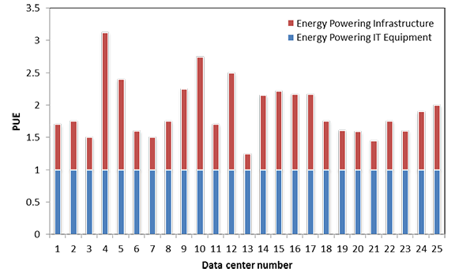Figure 2.19: PUE of 25 data centers studied by LBNL (Lawrence Berkeley National Labs, 2007).
The PUE allows companies to identify areas for improvement, address these areas, and monitor the progress in PUE over time. Google publishes quarterly PUEs for their actual data centers, as shown in Figure 2.20. Because Google's data centers are mostly in the northern hemisphere, the average PUE typically rises in the summer because they require increased use of the cooling equipment.
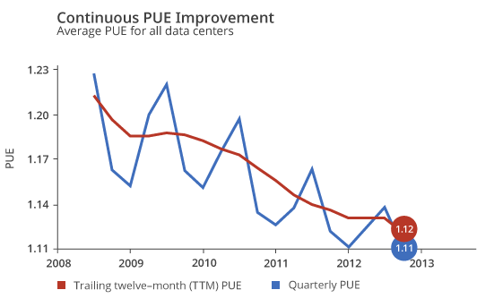Figure 2.20: PUE data for all large-scale Google data centers. [1]
Google improves the efficiency of its data centers using five methods. [1] First, they accurately measure and record the PUE as often as possible. Second, they design good air containment to limit the mixing of hot and cold air. Third, they increase the cold air temperatures because equipment manufacturers allow their equipment to run within aisles at higher temperatures. Fourth, they utilize free cooling whenever possible. This possibility is determined by the geographical location of their data centers and the number of hours per year that allow the use of cool ambient air, evaporating power, and large thermal reservoirs. Fifth, they minimize power distribution losses by eliminating several power conversion steps. The lowest recorded PUE to date at a Google data center is 1.08, which is around 92% efficiency.
PUE simply measures the efficient use of power. Understanding the energy contributors to PUE is important to improve data center design practices. However, PUE is not sufficient as the only measure because it does not account for the load on the IT equipment. If PUE is low, but the IT equipment is not doing useful work, then the data center is losing money. Some recent practices include utilizing a TCO metric that accounts for the cost of the server, which is the total cost of energy that it will consume while running a specific workload over its lifespan. Using this approach, data centers will utilize application-specific optimizations, which will lead to more effective use of the data center equipment.

PDU Branches (Optional Reading)
In an earlier module, you were introduced to a PDU, or power distribution unit. You also learned about inefficiencies related to multiple conversions. This section shows you the advantages of using three-phase power and some common pitfalls to avoid when choosing the size and number of PDUs. This section is optional reading as it goes into specific details concerning electrical engineering
There are several types of power distribution: rack level, row level, and room level. All of them have an input electrical feed and provide one or more branch circuits, with each branch protected by a circuit breaker (a safety device that will "trip" if there is an overload, stopping the flow of electricity). The difference with row-level PDUs is that they typically take a higher voltage and output to a lower voltage using a transformer (transformers generate heat, so you will also find cooling fans inside a row-level PDU).
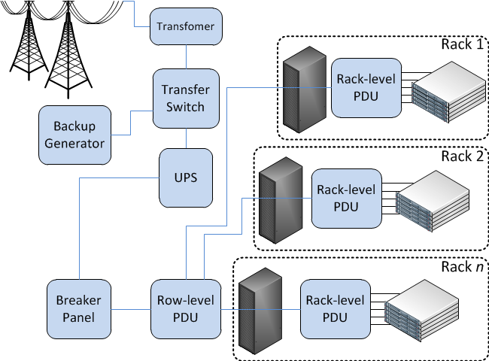Figure 2.21: Row-level and rack-level PDUs.
Three-phase power (often denoted with Greek letter phi [3Φ]) is how AC electricity is generated and transmitted, with each phase a sine wave that is 120 degrees apart. It is not common to have three-phase power in homes, but it is common in industrial buildings and a requirement in any modern data center. It is important to keep each phase as evenly loaded as possible. You should not plug all servers into one branch before going on to the next—stagger them instead. The important thing to know is that the total power that can be handled by a three-phase circuit is greater than that of a single phase (1Φ) for each copper wire (same thickness/gauge).
Phase | 1Φ | 3Φ
Power Equation | W = V × I | 3 ×Vline × Iline3√
Wires Needed | Hot, Neutral, Ground | Phase1, Phase2, Phase3, Neutral, Ground
Watts/Wire | 1.0x | 1.8x
For example, given V = 120 volts and I = 15 amps, then single-phase power = 1800W per three wires; and given Vline = 208 volts and Iline = 15 amps, then three-phase power = 5410W per five wires. (Recall that it is only the current/amps that determines how thick the copper has to be.)
Knowing the maximum power of any branch is important for choosing the number and size of PDU(s) to power your IT equipment. U.S. electric code states that the line current should not exceed 80% of the rating of the breaker (or fuse).
Label (Amps) | 15 | 20 | 30 | 50 | 70
80% derated limit | 12 | 16 | 24 | 40 | 56
It is rare for a server to actually consume the number of watts that their power supply is rated. For example, a PSU is labeled as 975W, but the server might only consume 650W at maximum capacity. For this reason, it is useful to take power measurements of each new model of server at various loads (idle, 25%, 50%, 75%, 100%) before putting it into production.
did I get this

Power and Efficiency: PDU Branches
When designing a redundant system, it is common to have multiple independent paths from the power source to the IT equipment. You can think of redundant power (and cooling) systems like hard drives in RAID. Recall that in a RAID1 mirror, you withstand a drive failing, but you also lose half your capacity, which is analogous to 2N redundancy—you cannot load a single component (e.g., UPS, generator, PDU) greater than 50% of its original capacity. While in RAID5, you still withstand a single drive failure, but you get higher utilization of individual drives, which is what N+1 redundancy is like for power and HVAC equipment. The remaining (working) units have to absorb the workload of the failed unit.
For example, you have a 100kW load and desire to have redundant UPS. In a 2N system, you have two UPS, each capable of powering 100kW, but their normal load would be 50kW each. If you use three UPS units instead, each could be smaller and capable of handling 50kW each but having a normal load of 33kW. In this case, the utilization is higher (66% instead of 50%), so the UPS would also run more efficiently.
Although blade chassis and some larger 4U/5U servers have N+1 power supplies, most servers and network equipment are designed with 2N redundant power supplies. For this reason, in a traditional data center, you would run two independent power feeds to each rack. This way, if you lose power in one feed, the other can take over. You must be cautious, however, because when one of the two feeds fail, the other one gets double the load. Incorrect assumptions often lead to overloading a branch circuit, which goes unnoticed in normal conditions. Then when there is a single failure, it has a cascading effect, overloading the remaining branches and tripping the breakers. This single failure leads to some or all servers in a rack losing power completely.
did I get this

Power and Efficiency: Redundancy
You have a 100kW load and are using an N+1 design for UPS, with 3 + 1 = 4 UPS total.
You have 12 servers, each with dual-redundant PSUs, which are measured together to consume a maximum of 500W. You also have two power feeds (A and B) going to the rack. To each feed, a three-phase 208V PDU is attached. Each PDU has three branches (one per phase), each with a 20A breaker.

Data Center Redundancy
The following video (Video 2.5) covers some important aspects of data center redundancy:
Video 2.5: Data center redundancy.

Data Center Tier Classifications
Data centers can be classified based on reliability. In order to understand the four different tiers, as specified in TIA-942 standard, you must first know what is meant by the word reliable. Reliability is most frequently measured in uptime, or availability. A service that is 100% reliable is extremely difficult to guarantee, and, therefore, no companies will make that claim in their service-level agreement (SLA) to a customer. But if they did, it would be available to users every second of every year.
Tier | Name | Availability (%) | Downtime/Year
1 | Basic | 99.671 | 28 hr, 49.37 min
2 | Redundant components | 99.741 | 22 hr, 41.3 min
3 | Concurrently maintainable | 99.982 | 1 hr, 34.5 min
4 | Fault tolerant | 99.995 | 26.3 min
Tier 1 has non-redundant components, such as power, cooling, and network connections, which can lead to downtime for maintenance in addition to single points of failure (SPOFs) (service is disrupted if a single part of the overall system has a problem). Tier 2 still has a single path for power and cooling but adds redundancy, such as UPS and a generator. Tier 3 adds multiple paths for power (multiple UPS and PDUs from the source to the rack) and cooling (e.g., several CRACs feeding raised floors). Tier 3 allows for no interruptions from planned maintenance. Tier 4 is similar to tier 3, but all paths must be redundant and can continue operations at full capacity with at least one unplanned outage (e.g., losing main power or network provider, UPS failure, AC outage).
Even a tier 4 data center could incur downtime due to multiple simultaneous outages, as occurred for Amazon during a large thunderstorm in Virginia. [1]

Mean Time Between Failures (MTBF)
Sometimes, when you read material referencing availability and reliability, you will see the term nines used. Five nines or nine nines refers to the number of nines in a percentage of availability. Two nines is 99%, three nines is 99.9%, four is 99.99%, and so on.
You will also see the phrases mean time between failure (MTBF) and mean time to failure (MTTF) in the specifications for many individual components (e.g., hard drives, motherboards, power supplies). These are defined as the average number of hours that component is expected to last and are usually determined by the manufacturer using a sample of parts in more extreme conditions. However, reported failure rates in the field often are higher. For example, hard drives are rated 1 million hours or more, but they have been found to be 2 to 10 times higher, [1] and Google found drive failures rates to be 50% higher on average in their study. [2] The failure rate is 1/MTBF. For example, if the MTBF of a device is 100 hours, then the chances of that device failing in 1 hour is 1/100, 0.01, or 1%.
It is important to note that when determining the overall MTBF of a system that has non-redundant components, the MTBFs of each individual component add as a reciprocal. Formally,
1MTBFsystem=(1MTBFc1+1MTBFc2+. . .+1MTBFcn)
On the other hand, when a system consists of redundant components, required in both components simultaneously to have an overall system failure. The overall MTBF of the system is thus the product of the MTBFs of each individual redundant component of the system. Formally,

Data Center Components Summary
- Servers mount into racks, come in incremental heights, called rack units (e.g., 1U, 2U, 3U), and have various depths. Larger cases allow for more expansion and/or redundant components.
- Servers support more CPU sockets and DIMM slots than a desktop or laptop.
- There are many types of PCI express cards available to expand servers, including RAID controllers, network cards (1, 10, or 40 gigabit Ethernet), Infiniband HCAs, storage HBAs, and coprocessors/accelerators, such as GPUs.
- HDDs and SSDs can attach to a host through SATA or SAS and are used as building blocks for larger storage arrays, often employing RAID technology. These arrays can be a directly attached DAS, a remote block device SAN (using FC or iSCSI), or a remote file server NAS (using CIFS or NFS). Distributed file systems use many servers or arrays in parallel to increase performance and resiliency.
- Data center networking topology is often multitier, with the lowest tier switches in the same rack (top of rack) or in the same row (end of row).
- Ethernet remains the de-facto standard for data center networks, is available at a variety of speeds, and works over copper or fibre-optic cables.
- Infiniband is a high-speed interconnect, now popular with HPC, and gaining acceptance in enterprise IT data centers.
- Data centers and server rooms contain racks, raised floors, and cable trays and are designed with strong physical security.
- Power distribution comes from the utility company or a backup generator and typically goes through a UPS, through PDUs, to the rack, and then server level. Some systems improve efficiency by converting AC to DC fewer times and/or decentralizing the UPS.
- Servers are most often cooled through CRACs, which push cold air under a raised floor while taking in hot air and removing the heat through a chilled water loop. That loop is attached to a chiller, which itself removes heat by venting through the air or a secondary loop to a cooling tower. Higher densities/efficiencies can be achieved using in-row cooling with hot-aisle containment. Evaporative cooling is also becoming popular for data centers.
- Safety is important for both equipment and personnel. FM-200 provides fast, safe fire suppression. All metal surfaces should be properly grounded, and safety equipment should be used appropriately.

MTBFsystem=MTBFrc1×MTBFrc2×. . .×MTBFrcn
did I get this

Availability and Reliability
Assume you have 20,000 independent hard drives of a particular model in your data center, each with a manufacturer specified MTBF of 1 million hours. Assume you do not trust the manufacturer-specified MTBF, so divide by two to get 500,000 hours.
One factor that is often overlooked when considering uptime is human error. No matter how much redundancy is designed into the system, even if it is properly implemented and maintained, there is some likelihood of a mistake being made by a person. The result of which eventually leads to a service being unavailable (downtime). Some mistakes can be prevented through policy, specifying standard configurations, good documentation, and change management.
When it comes to large cloud deployments, there is little focus on the hardware resiliency of an individual server. When 10,000 or more servers are working together as part of a single application, the application itself builds in the fault tolerance (more on that in the next unit, "Resource Sharing"). In this situation, a single server failure, or even several, will not disrupt the application/service. Small and medium sized businesses, or even a large enterprise that has legacy applications, cannot afford to author these cloud-style, fully customized applications, so they rely on third-party software, most of which does not respond well to hardware failures. Instead, cloud providers will focus on server hardware that is inexpensive and as energy efficient as possible, removing unneeded parts.

Percentage of availability in year = Total time service is availableTotal time in a year
The percentage of availability can be measured in hours, minutes, or seconds. Downtime is calculated as:
Downtime = (1 − availability in a year)×total time in a year
For example, the calculation for the downtime that a tier 4 data center should achieve is as follows:
1−0.99995 ×60 min × 24 hr ×365 days = 26.28 min
did I get this

Availability and Reliability
MY RESPONSE...

